











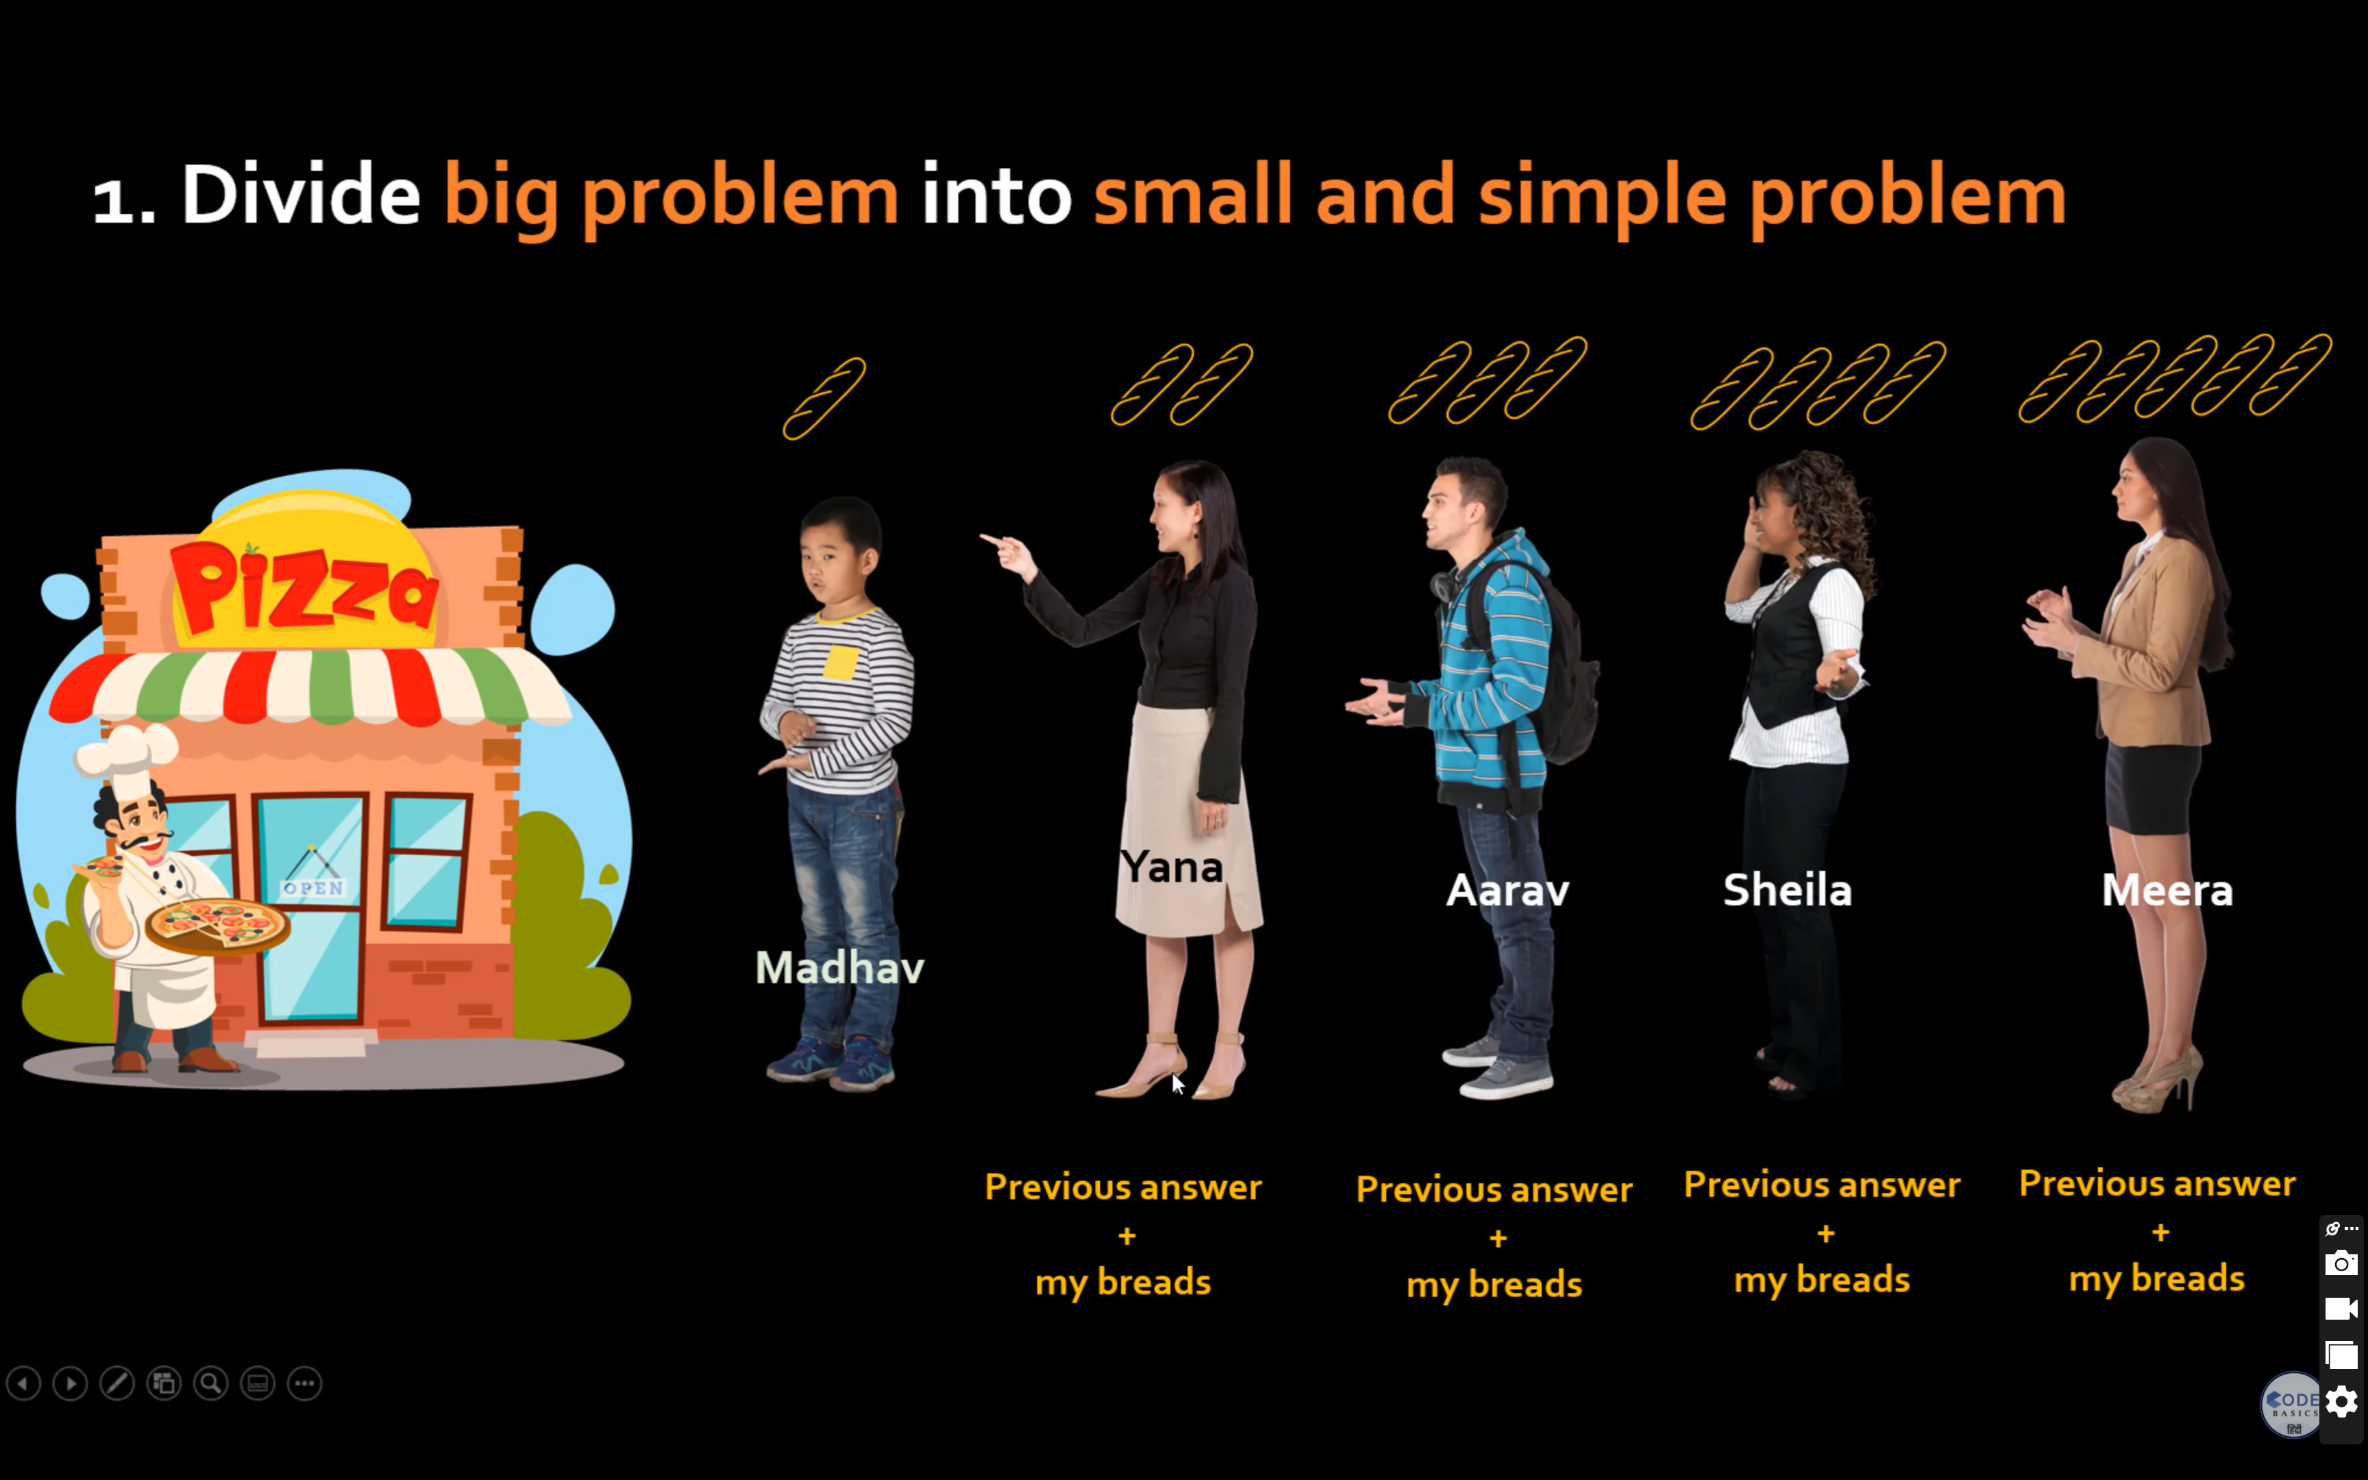

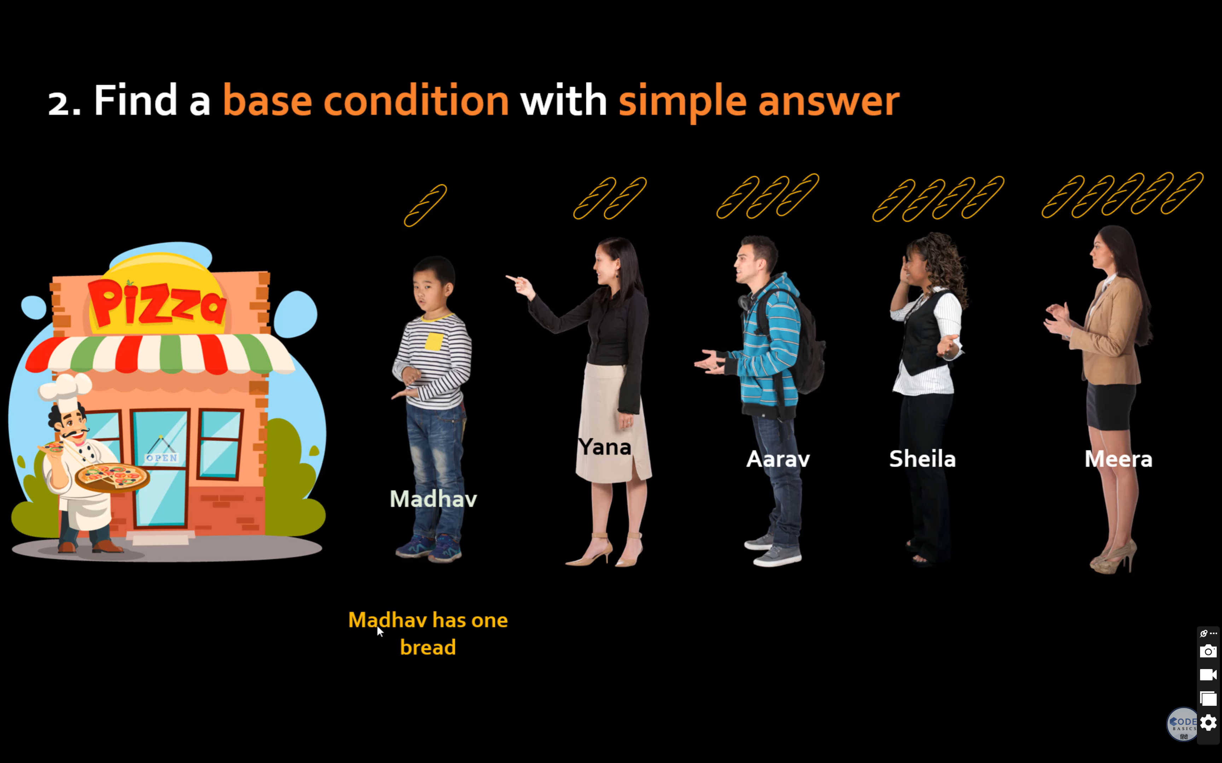

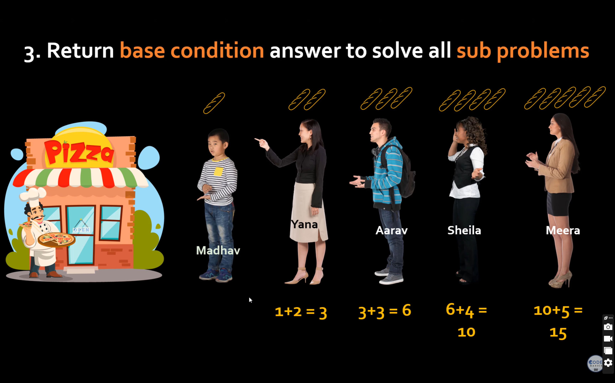

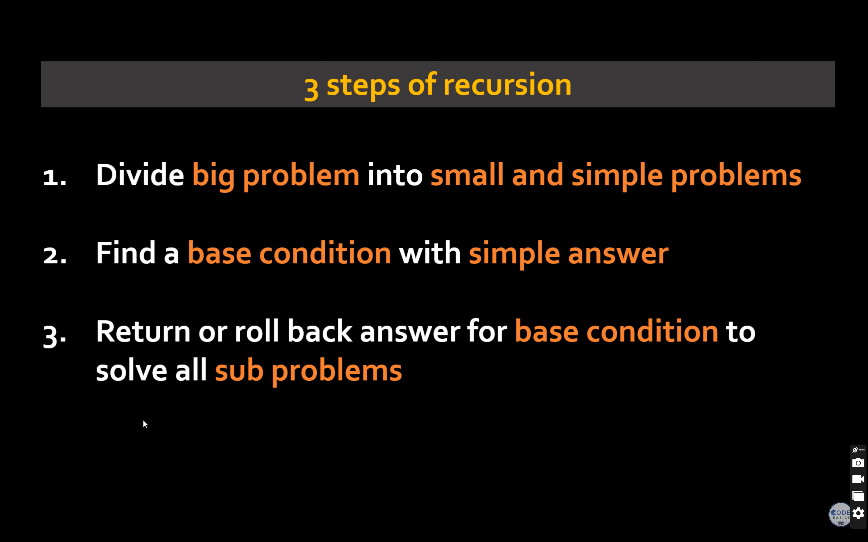

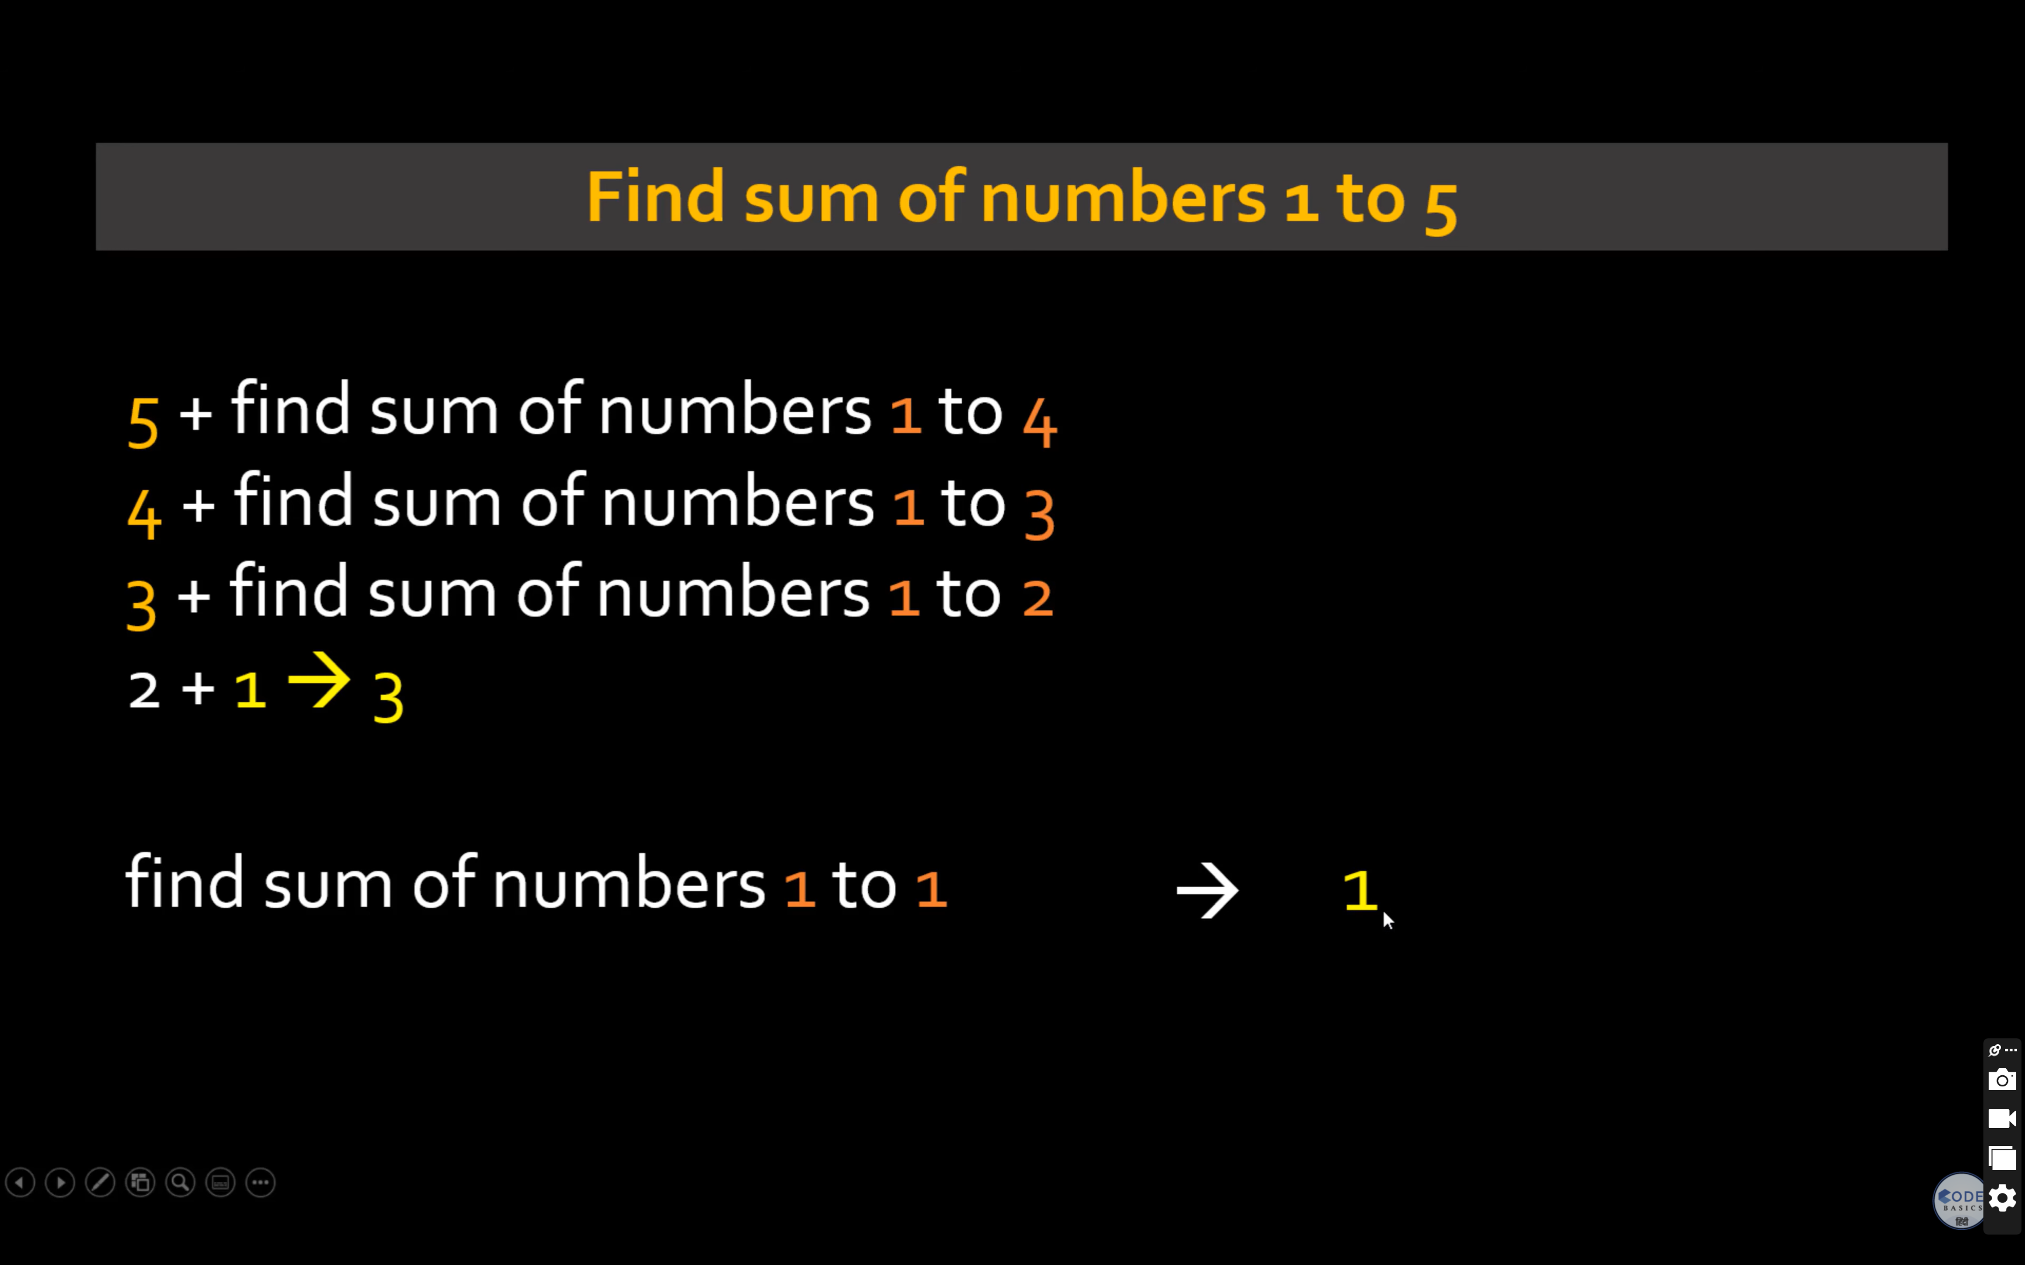

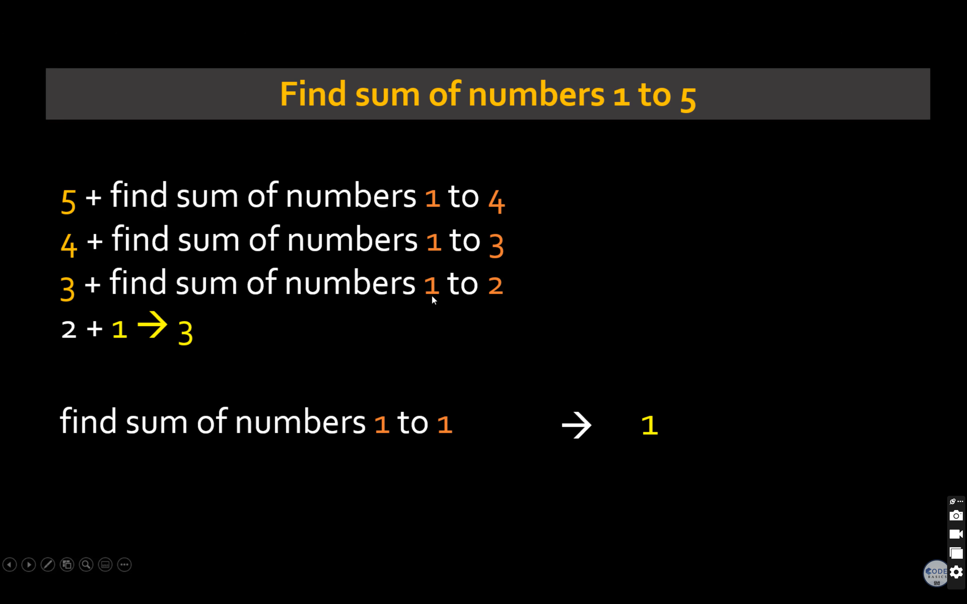

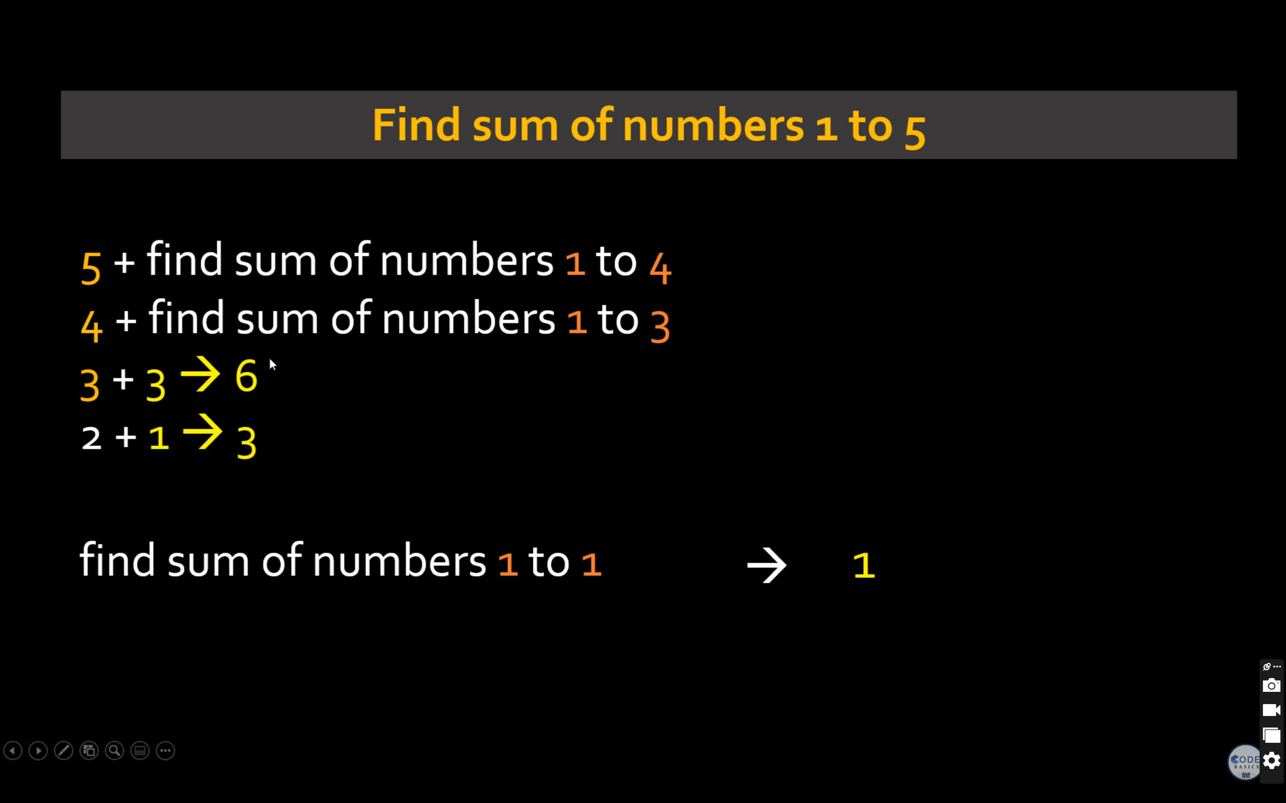

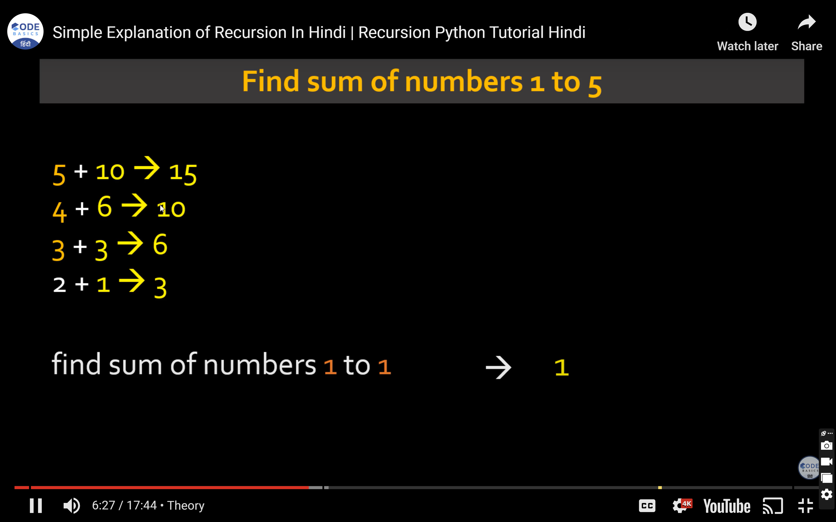

function recurSum(n):

if n <= 1:

return n

return n + recurSum(n - 1)

end function

input n

sum = recrSum(10)

print sum

// Online C# Editor for free

// Write, Edit and Run your C# code using C# Online Compiler

using System;

public class HelloWorld

{

public static void Main(string[] args)

{

Console.WriteLine (Sum(10));

}

static int Sum(int n)

{

if(n<=1) return 1;

else

return n + Sum(n-1);

}

}

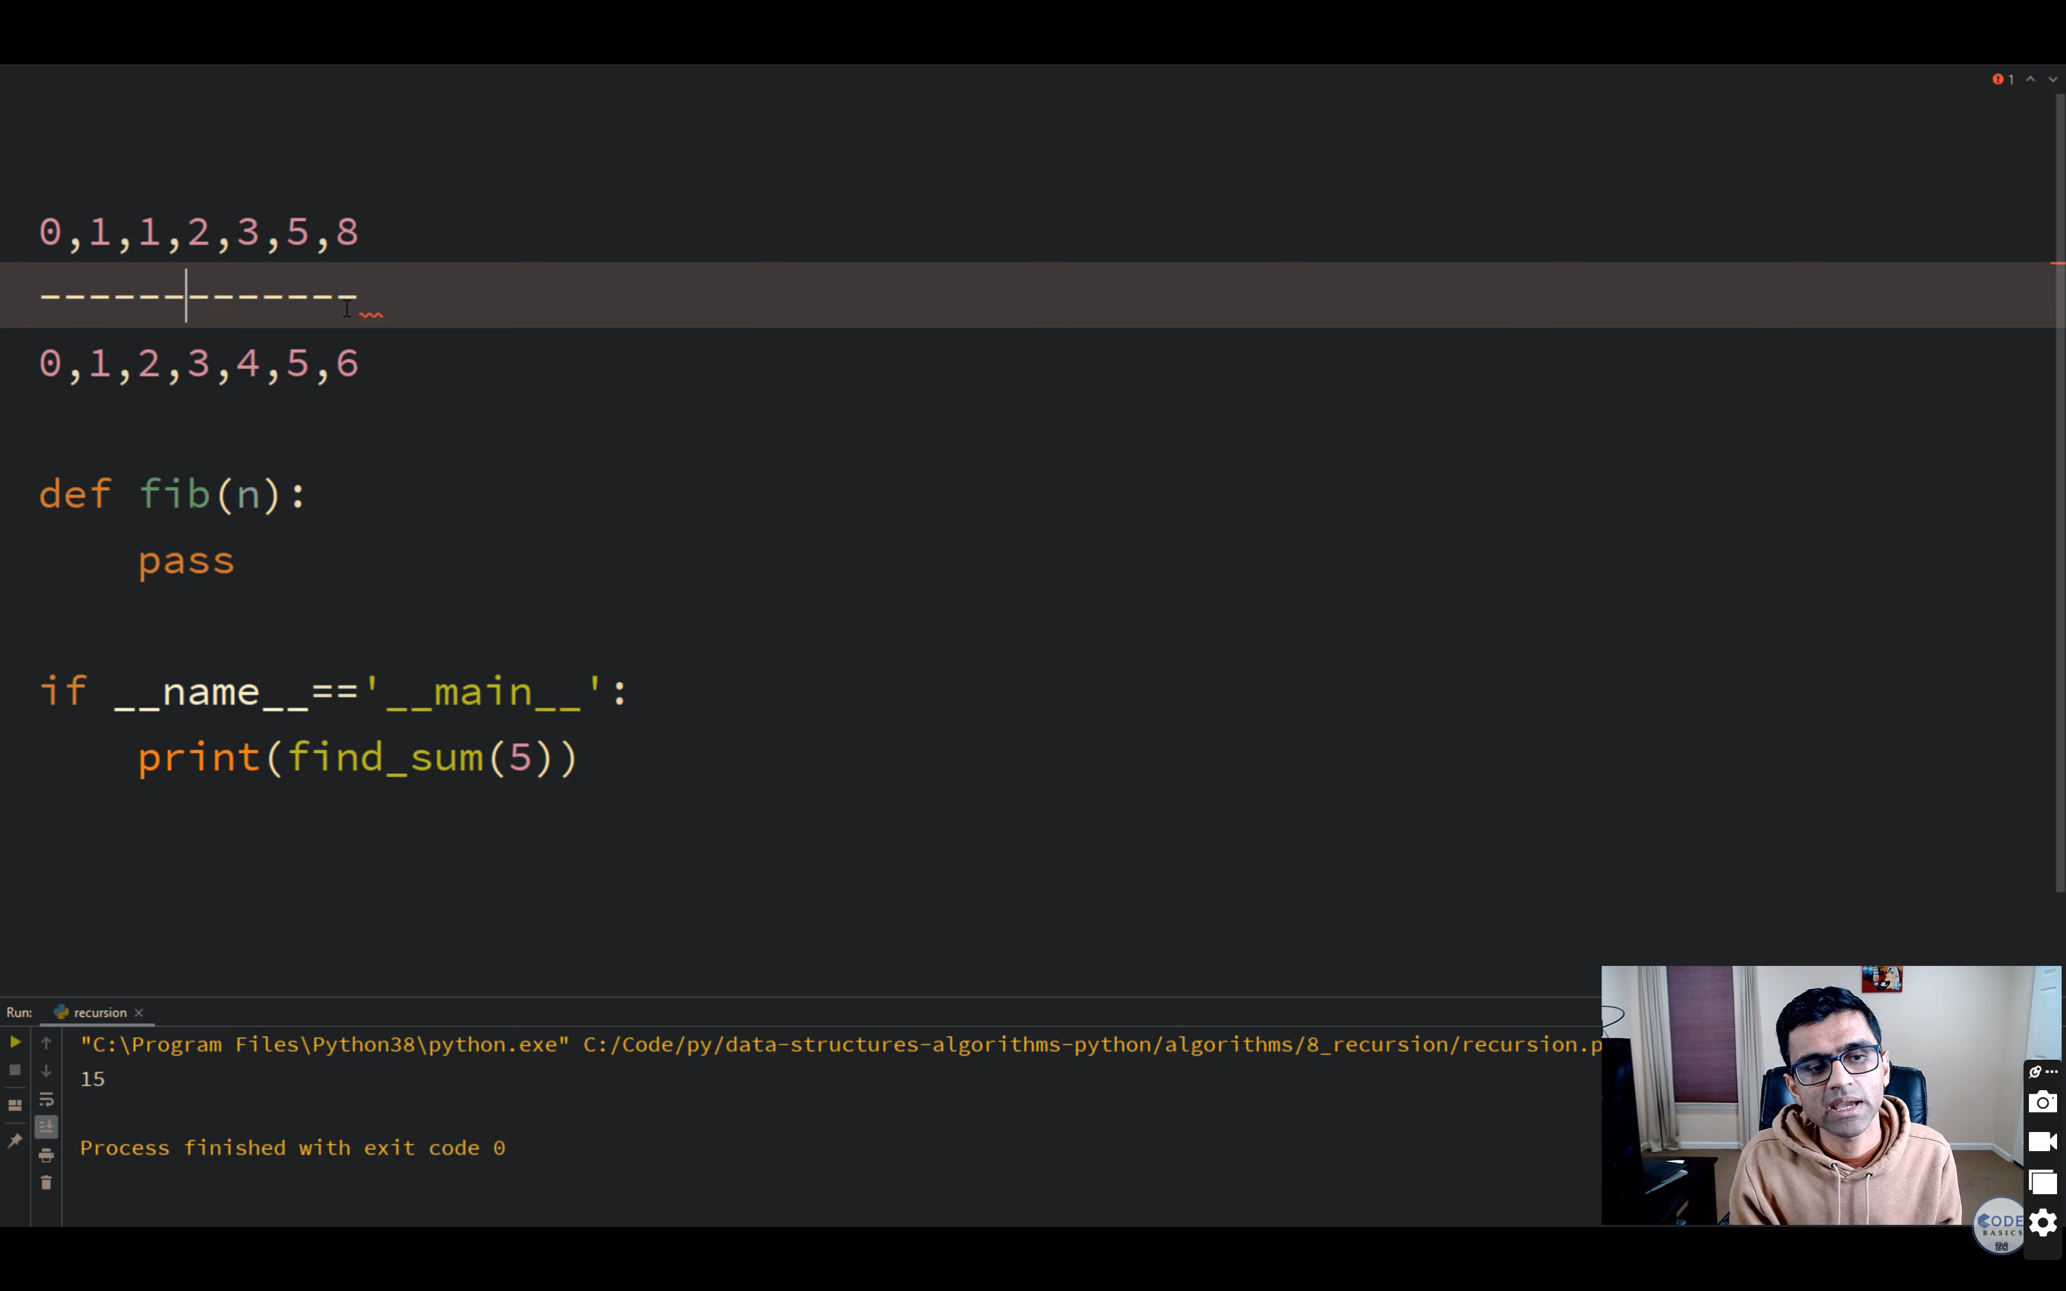

Fibo Series

1 1 2 3 5 8 13 21

Fibo(n)

Begin

if n <= 1 then

Return n;

else

Return Call Fibo(n-1) + Call Fibo(n-2);

endif

End

Non recursive

int nonRecFibo(int n){

int i, a, b, f;

if(n <= 1)

return n;

else{

a = 0, b = 1, f = 0;

for(i = 2; i <= n; i++){

f = a + b;

a = b;

b = f;

}

}

return f;

// Online C# Editor for free

// Write, Edit and Run your C# code using C# Online Compiler

using System;

public class HelloWorld

{

public static void Main(string[] args)

{

Console.WriteLine (Sum(10));

for(int i = 0;i<10;i++)

Console.Write(Fib(i) +" " );

Console.Write(IterativeWayToPrintFib(10));

}

static int Sum(int n)

{

if(n<=1) return 1;

else

return n + Sum(n-1);

}

static int Fib(int n)

{

if(n<=1) return 1;

else

return Fib(n-1) + Fib(n-2);

}

static int IterativeWayToPrintFib(int n)

{

Console.WriteLine("Using IterativeWayToPrintFib");

int t1=0, t2=1, next=0;

for(int i = 1 ;i<=n ;i++)

{

Console.Write(t1 + " ");

next = t1+t2;

t1= t2;

t2= next;

}

return 0;

}

}

Binary Search

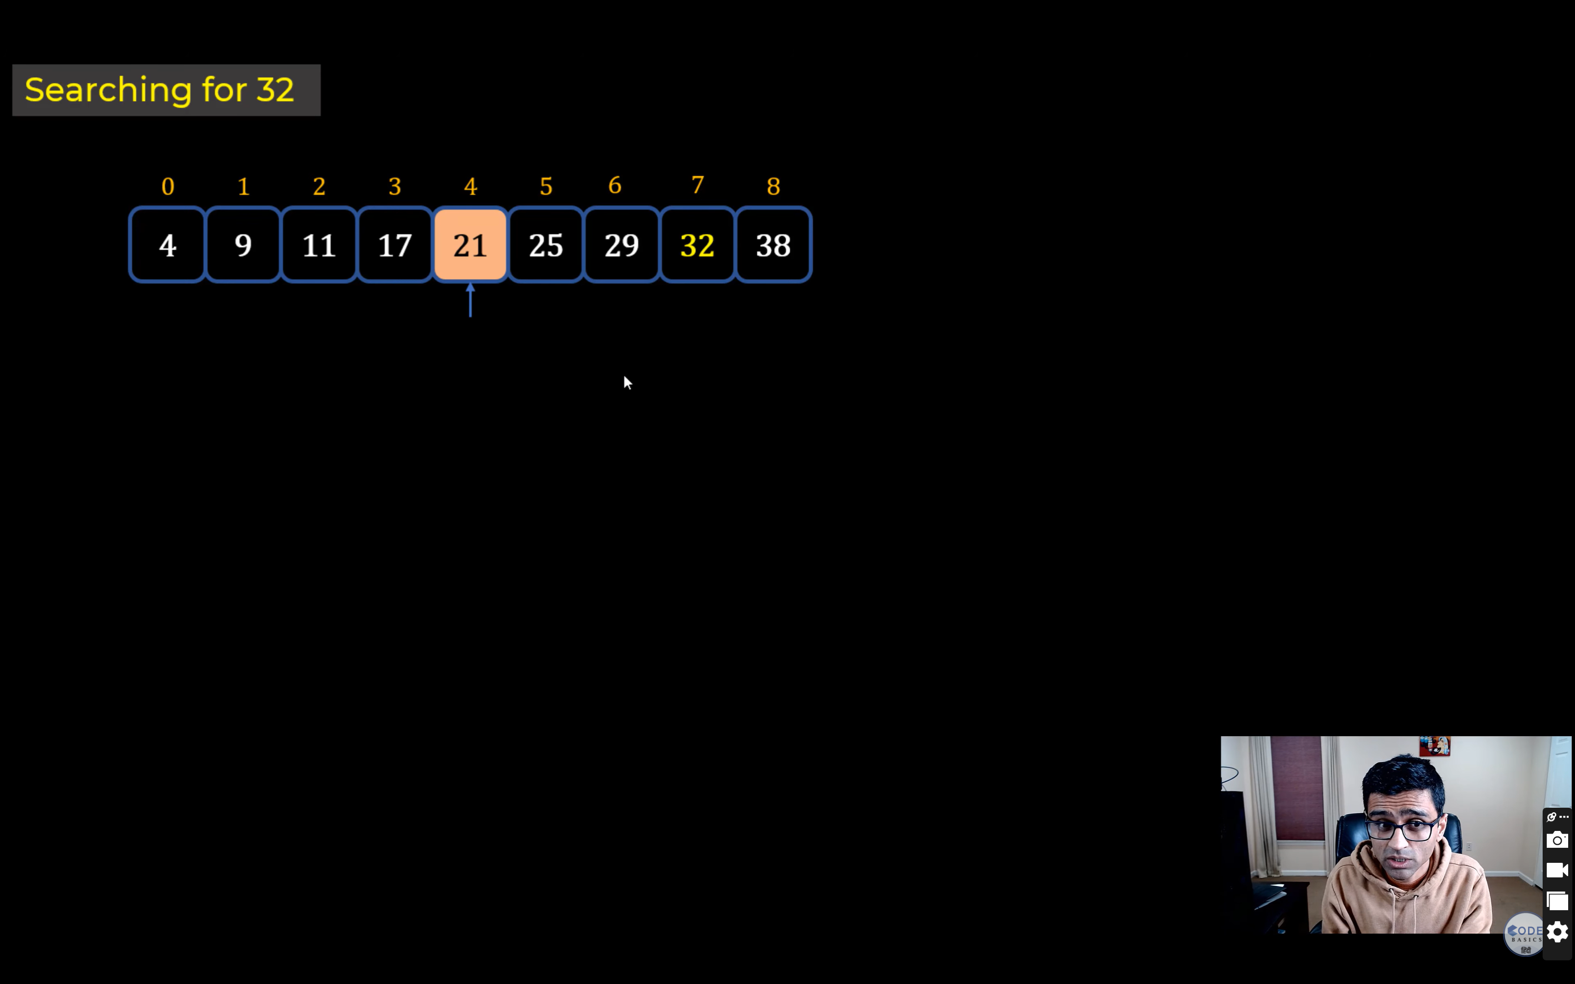

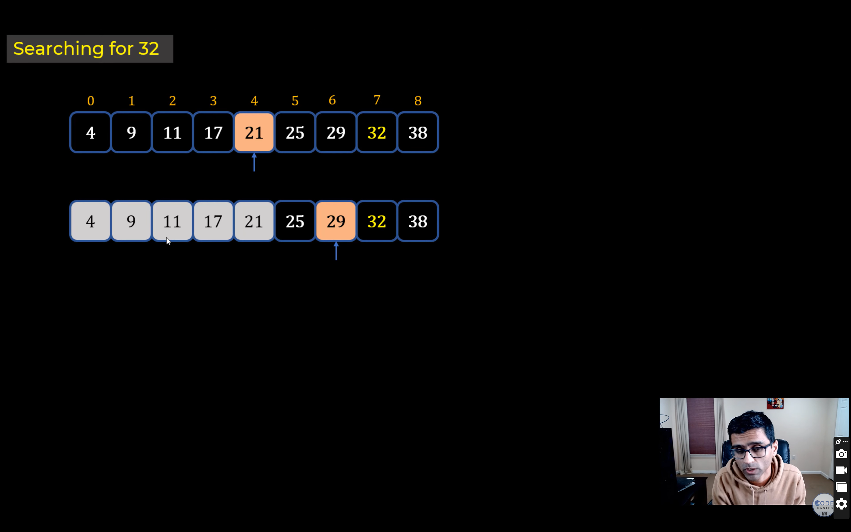

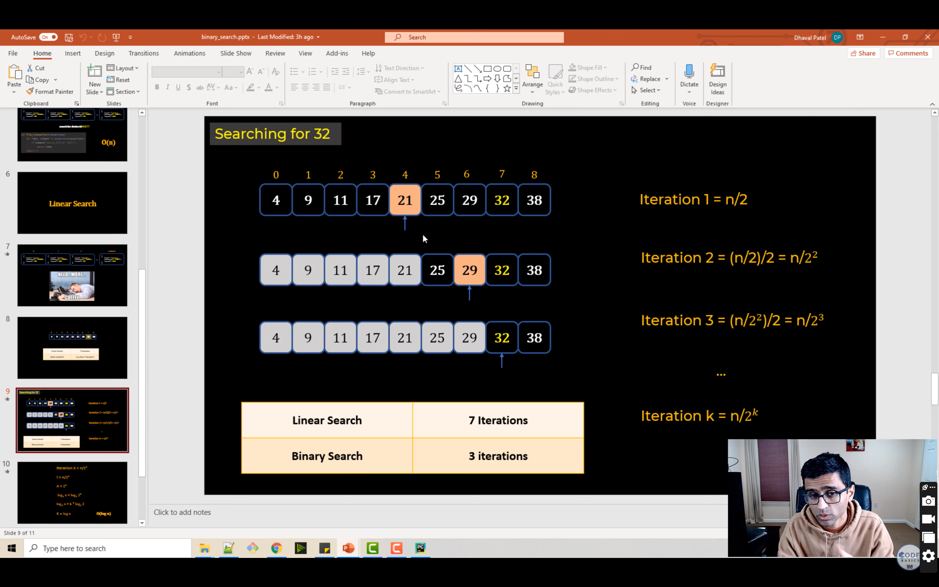

<https://medium.com/@williambdale/recursion-the-pros-and-cons-76d32d75973a>

<https://www.techiedelight.com/binary-search/>